Title: Times New Roman 16pt Bold∗

Kim, Gil-Dong ∗∗
XXXX-XXXX-XXXX-XXXX
Lee, Gil-Dong ***
XXXX-XXXX-XXXX-XXXX
Park, Gil-Dong ****
XXXX-XXXX-XXXX-XXXX
Table of Contents
1. Chapter
1.1 Subchapter
2. Chapter
3. Chapter
Abstract
Write down A brief summary (150-250 words) of the paper here in Times New Roman(TNR), 9pt, default letter setting, and single spacing. Try to keep the abstract a single paragraph without an indent for the first word.
Keywords: 4 to 6 keywords, separated by commas.

1. TNR 12pt Bold
1.1 TNR 11.0pt Bold
1.1.1 TNR 10.0pt Bold
The setting is based on A4 and with normal margins, TNR 10pt, a line spacing of 1.3, and an indentation of 2 spaces in the first line. If you upload the file to Collab(Online Co-Authoring Tool from AccessON), create a project, and apply styles for each element, the metadata for the paper will be automatically filled in and you could archive your paper more conveniently through Collab Pen. Use endnotes when you cite references.

Table 1. Table Title
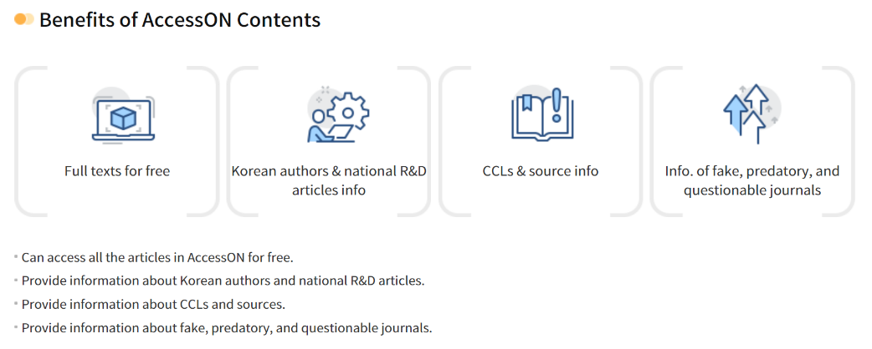
Figure 1. Figure Title

∗ This research is supported (or Funded) by Funding Agency (or Institution).
∗∗1st Author: Department, Institution, Address, Email
***Coauthor: Department, Institution, Address, Email
****Corresponding Author: Department, Institution, Address, Email
Gallman, Robert E. (1970). “Self-Sufficiency in the Cotton Economy of the Antebellum South.” Agricultural History 44-1 5-23. References Reference Style is depending on the journal with TNR 9pt, a line spacing of 1.3, and an indentation of 2 spaces from the second line. Gallman, Robert E. (1970). “Self-Sufficiency in the Cotton Economy of the Antebellum South.” Agricultural History 44-1 5-23. Shang, Wenyi; Underwood, Ted(2023). “Civil Service Examination Records and Political Independence in the Autonomous Northeastern Region during the Second Half of the Tang Dynasty (755–907 C.E.).” International Journal of Digital Humanities. https://doi.org/10.1007/s42803-022-00054-7

